How to change speaker name

What's the speaker name?
Speaker name is a nickname of your Q Station will be displayed in all Air Play or DLNA supported music player.

PC
1. Switch Wi-Fi connection to your Q Station's Wi-Fi connection. The SSID could be BellnetXXXXXX (XXXXXX is the last 6 characters of your Q Station's serial number)
2. Access 172.16.0.1 with your Internet browser
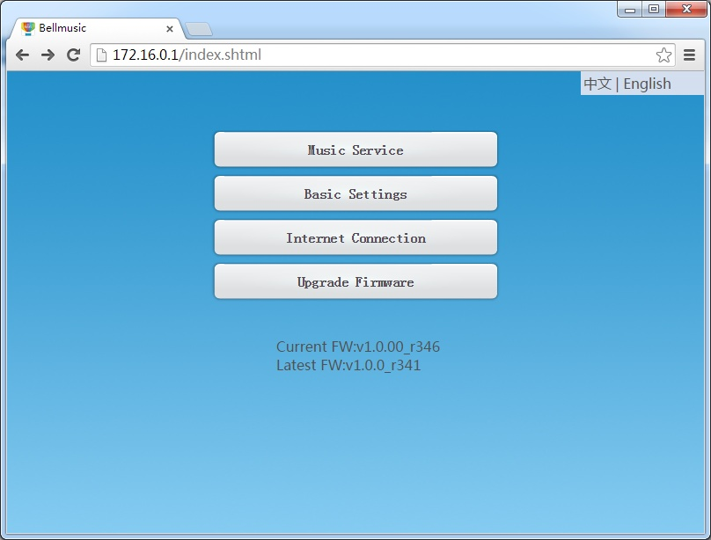
3. Click 'Music Service' to go into the setting page
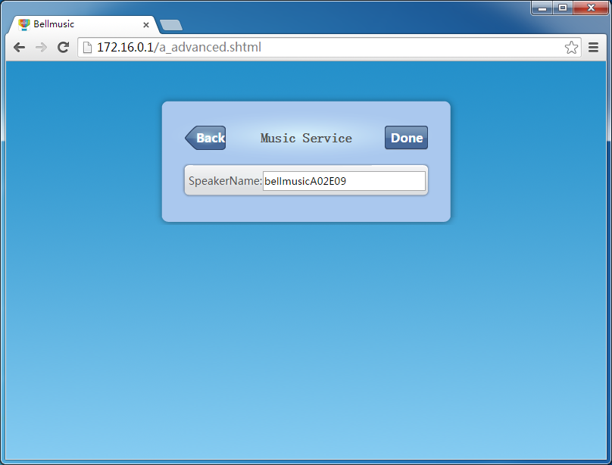
4. Change the speaker name to what you want, then click 'Done' button to take this change effect immediately.

IOS
1.Search 'Bellq' from Apple apps store and install it on your IOS devices.
2. Run BellQ and click setting icon, then you'll see web page of Q Station.
3. Click 'Music Service' and you'll see the following page.

4. Change the speaker name to what you want, then click 'Done' button to take this change effect right now.

Android
1. Install 'Bellq' or 'qlight' from Google Play.
2. Run BellQ and click setting icon, then you'll see the home page of Q Station.
3. Click 'Music Service' and you'll see the following page.

4. Change the speaker name to what you want, then click 'Done' button to take this change effect right now.

